Assignment- BMICalculator

1. First import the repo from https://github.com/ygoyal25/10x-js-assignments.git to your repo
2. Then clone the repo in your local machine
3. git checkout -b "BMICalculator"
4. Open assignments/bmi_calculator/BMICalculator.md  file for the assignment.
5. Complete the assignment in assignments/bmi_calculator/bmi_calculator.js file
6. Please follow the instructions in assignments/bmi_calculator/BMICalculator.md for running the testcases.
7. Proceed with Staging using command git add . or use Vs code extension
8. Git commit or use Vs code extension
9. Git Push or use Vs code extension
10. Create the Merge Request as mentioned in below screenshots.
    1. Select the branch that checkout in step 4

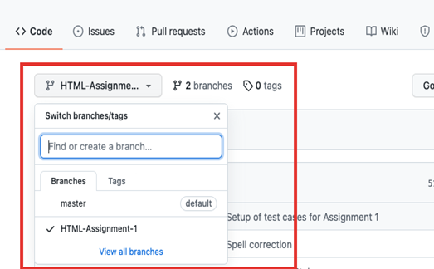

* 1. Click on “Pull request”
  2. 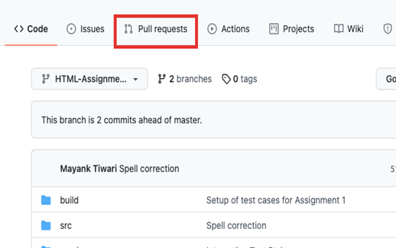
  3. Click on “New Pull Request”

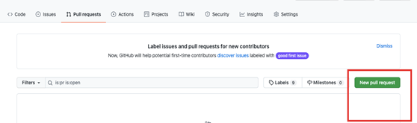

* 1. Select the branch that checkout in step 4

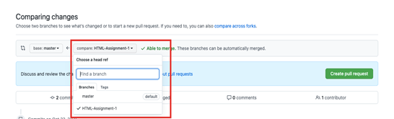

* 1. Create a pull request and share link of Request as your submission.